<http://data.worldbank.org/data-catalog/world-development-indicators?cid=GPD_WDI>

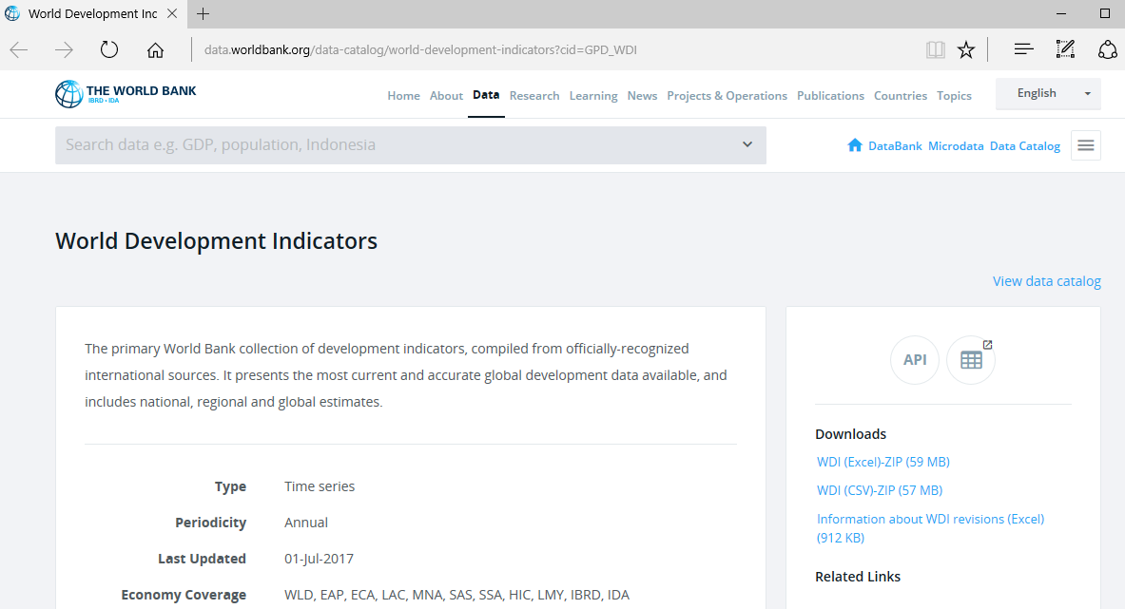



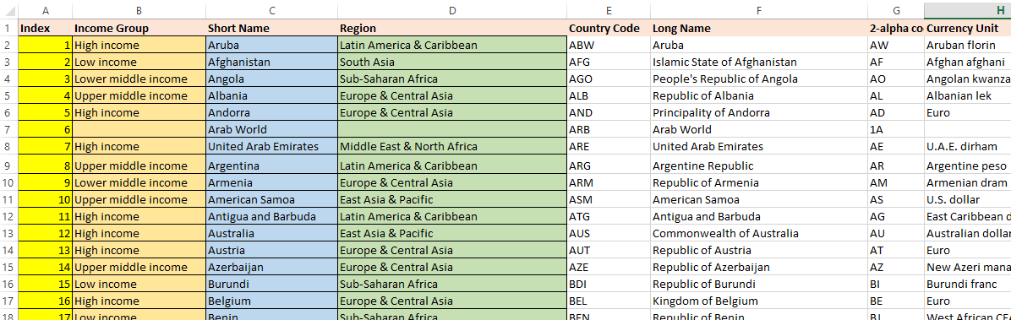

We will use **Income Group** as the “source” and the country **Short Name** as the “target”.

We will evaluate **Region** for correlations.

Note: **Index** is a created column, not original to the source data.

